**Project Design Phase-II**

**Technology Stack (Architecture & Stack)**

|  |  |
| --- | --- |
| Date | 2 July 2025 |
| Team ID | LTVIP2025TMID50858 |
| Project Name | ToyCraft Tales: Tableau's Vision into Toy Manufacturer Data |
| Maximum Marks | 4 Marks |

**Technical Architecture:**

The Deliverable shall include the architectural diagram as below and the information as per the table1 & table2

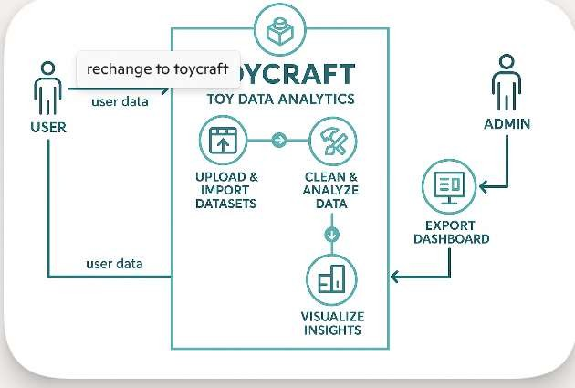

Guidelines:

Include all the processes (As an application logic / Technology Block)

Provide infrastructural demarcation (Local / Cloud) Indicate external interfaces (third party API’s etc.) Indicate Data Storage components / services Indicate interface to machine learning models (if applicable)

**Table-1 : Components & Technologies:**

|  |  |  |  |
| --- | --- | --- | --- |
| **S.No** | **Component** | **Description** | **Technology** |
| 1. | User Interface | Interface to visualize Toy data insights (dashboards, graphs) | Tableau Public, HTML, CSS |
| 2. | Data Preparation Logic | Scripts used to clean, filter, and prepare data for analysis | Python (Pandas, NumPy) |
| 3. | Data Analysis Logic | Logic to compute KPIs and summaries (e.g., avg speed, efficiency) | Tableau Calculated Fields, Excel |
| 4. | Data Source | Datasets used for Toy analysis . | CSV Files, Excel Sheets |
| 5. | Database (optional) | Store dataset backups or Tableau extracts. | MySQL / SQLite (optional) |
| 6. | Cloud Storage (optional) | Local storage for dashboards, data files, screenshots | Google Drive, IBM Cloud Object Storage |
| 7. | File Storage | Local storage for dashboards, data files, screenshots | Local Filesystem |
| 8. | External API-1 | Weather data for charging decision insights (optional) | OpenWeatherMap API / IBM Weather API |
| 9. | External API-2 | EV Station Location / Map data (optional) | Google Maps API / NREL API |
| 10. | Infrastructure | Platform used for development and visualization | Local System, Tableau Public Cloud |

**Table-2: Application Characteristics:**

|  |  |  |  |
| --- | --- | --- | --- |
| **S.No** | **Characteristics** | **Description** | **Technology** |
| **1.** | Open-Source Frameworks | Frameworks and tools used for data cleaning and visualization | Python (Pandas, NumPy), Tableau Public, Jupyter Notebook |
| **2.** | Security Implementations | Dataset stored and shared securely; minimal exposure to sensitive data | File-level protection, Google Drive Access Control, No login data used |
| **3.** | Scalable Architecture | Project can scale by integrating more datasets, APIs, or deploying via cloud BI tools | Tableau Public (scalable dashboard), Cloud-based deployment (optional) |
| **4.** | Availability | Tableau Public Cloud,Google Drive download offline | Tableau Public Cloud, Google Drive, Local System |
| **5.** | Performance | Lightweight dashboards with optimized data sources; performs well on local/cloud | CSV Optimization, Filtered Data in Tableau, Extract Mode |